JAGAT J L

Module 5 - Spring Core and Maven
Exercise 2: Implementing Dependency Injection
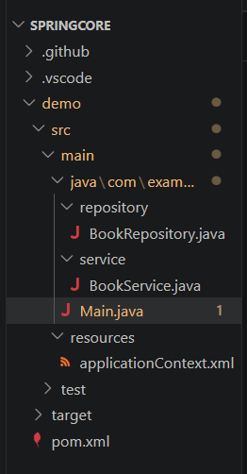
applicationContext.xml
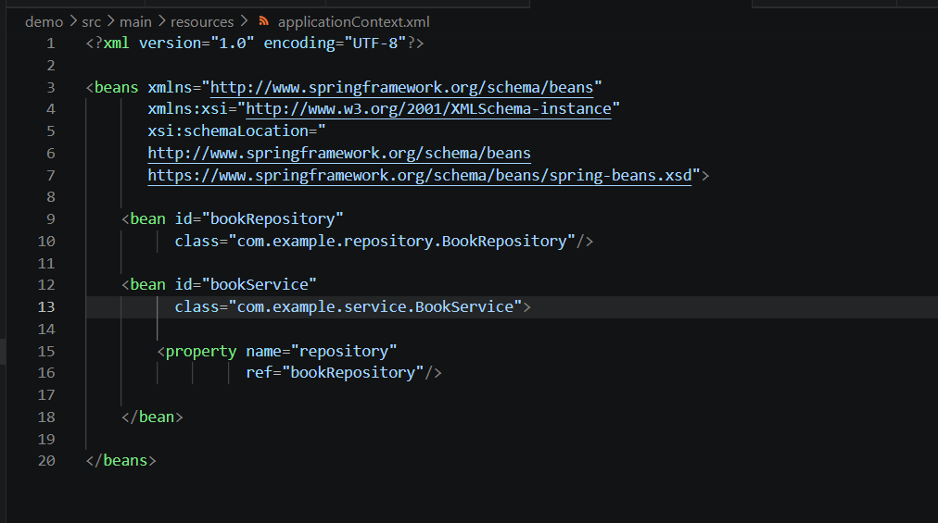
BookService.java
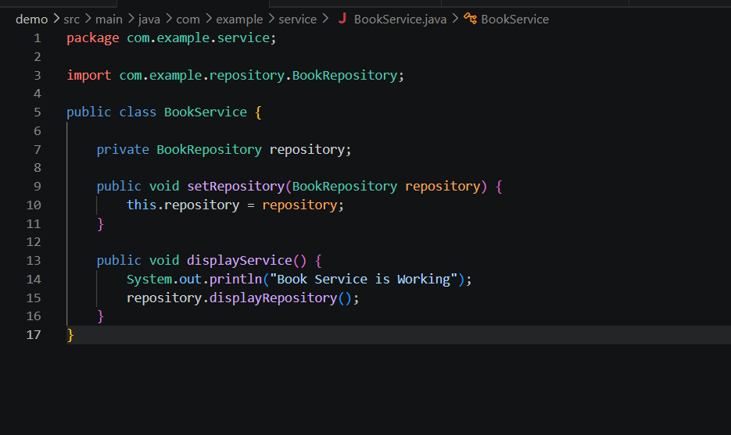
Main.java
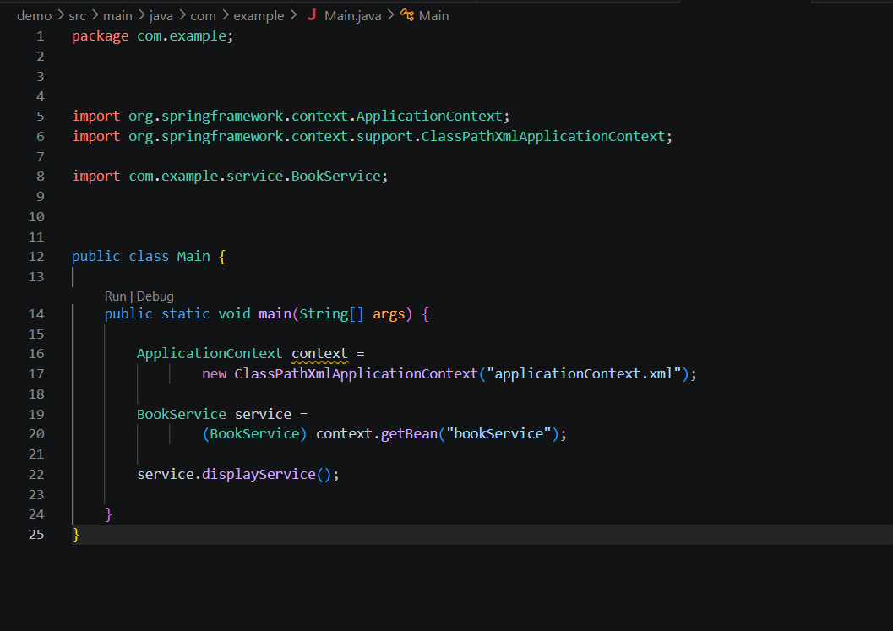
Output
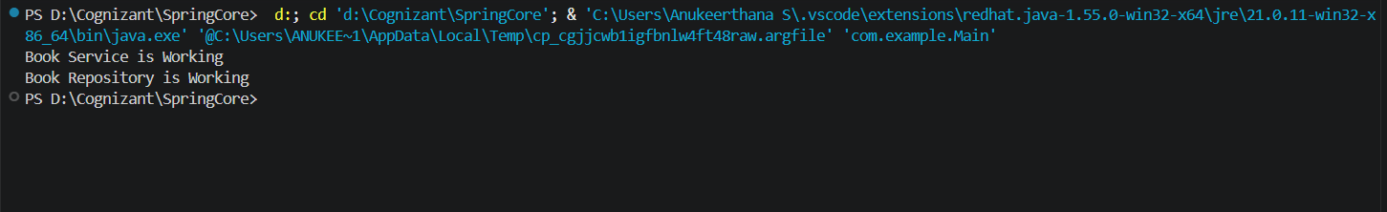
Explanation
1. Spring IoC (Inversion of Control)
Spring IoC is a feature of the Spring Framework that manages the creation and lifecycle of objects (called beans). Instead of creating objects using the new keyword, the Spring IoC container creates and manages them based on the configuration provided in applicationContext.xml.
2. Dependency Injection (DI)
Dependency Injection is a design pattern in which one object receives its required dependency from the Spring container instead of creating it manually.
In this exercise:
- BookService depends on BookRepository.
- Spring automatically injects the BookRepository object into the BookService object using setter injection.

